Industrial Training Report

On
COMPLAINT MANAGEMENT SYSTEM

At
Telecommunications Consultants India Ltd (TCIL)

COMPANY PROFILE

TCIL, a prime engineering and consultancy company, is a wholly owned Government of India Public Sector Enterprise under the administrative control of the Department of Telecommunications(DOT), Ministry of Communications and Information Technology, Government of India. TCIL was set up in 1978 for providing Indian telecom expertise in all fields of telecom, Civil and IT to developing countries around the world. Company's core competence is in the fields of Switching, Transmission Systems, Cellular services, Rural Telecommunication, Optical fibre based backbone transmission systems, IT & Networking Solutions, Application Software, e-Governence, 3G Network, WIMAX Technology and also Civil construction projects.

MISSION
"To excel and maintain leadership, in providing Communication Solutions on turnkey basis in telecommunication and information technology service sector globally".

ORGANISATION
Telecommunications Consultants India Ltd (TCIL) is a leading ISO - 9001:2000 certified public sector undertaking. TCIL, a premier telecommunication consultancy and engineering company with a strong base in Telecommunication & Information Technology (IT), was incorporated in 1978 by Department of Telecommunications (DOT), Government of India under the aegis of Ministry of Communications, headed by Minister of Communications and Information Technology.
There are four PSUs under DoT. TCIL is one of them. Other being
Bharat Sanchar Nigam Limited(BSNL)
Mahanagar Telephone Nigam Ltd.
ITI
Backed by the vast network of DoT / BSNL/MTNL, in terms of trained and experienced manpower, research & development and training facilities, TCIL has made rapid strides. Today TCIL offers total telecom solutions for projects. TCIL has working/ is works in almost 45 Countries mainly in Middle East Africa, South-East Africa, South-East Asia and Europe. The Organisational Structure is formed with the objectives of providing globally world-class technology and Indian expertise in all fields of Telecommunications and to provide total Quality management & excellence in project execution.

SERVICES
TCIL provides consultancy services in various sectors such as:
- Telecom Consultancy
- IT Consultancy
- Architechtural Consultancy

TELECOM CONSULTANCY
In the telecom consultancy, TCIL provides services to carry out strategic and basic planning, feasibility studies, network design and architecture, technical specifications, preparation of tender documents, tender /bid evaluation, and provide full turnkey solutions to be built, suggest and assist the govt/ public/private sector in formulating the
- Revenue/Business Model like BOOT/BOO/any other
- Defining vendor's eligibility/qualification criteria.
- Selection of vendors or consortium of vendors.
- Outsourcing strategies/ models
- Evaluation & finalising the bids.
- Contract finalisation with selected service provider.
- Supervision of implementation and acceptance testing.
- Long-term service contracts with vendors/ service contractors
- Consultancy studies relating to WLL technologies.
- Techno-economic studies regarding DTH Services in India.
- Operation and maintenance services for the new and on going systems.

IT CONSULTANCY
TCIL provides consultancy services to cover OSI model from Physical to Application layer. Range of services includes Network Design, Security Architecture, Enterprise Management and Customized Applications to meet specific business needs of the client.
Services in the aforesaid technology areas includes: Framing IT strategies & policies, Planning and System Study, Design and architecture of System, Finalization of Technical specifications, Customization and development of Application Soft wares and other services covering complete life cycle of the projects.
TCIL has developed demonstrable expertise through successful implementation of IT projects in each of the following domain areas:

- Telecom
- Government
- Post & Telegraph
- Defense & Police
- Banking and Finance
- Oil & Petroleum
- Cyber Parks
- Power

ARCHITECHTURAL AND CIVIL CONSULTANCY
TCIL caters to the planning of Telecommunication / Postal and all types of buildings for operational and administrative use, training and housing complexes in India and abroad. TCIL has also developed expertise for Intelligent Building Systems.
TCIL has recently provided Architectural Consultancy for Sudan Electronic City and also for Cyber Park at Algeria. It has provided its services for building projects in Somalia, Nigeria in addition to India. TCIL own complex at Greater Kailash with all modern Intelligent Building Systems is testimony to the expertise in this area.
TCIL has recently diversified into Road projects and is able to provide services to projects related to roads including National Highways.

The present major projects under various stages of implementation are:
- Cyber city at Sidi Abdellah,Alger,Algeria
- Sudan Cyber City Project
- National Highway project in Assam
- BoT Road Project in Punjab
- State Highway Projects in Madhya Pradesh
- Pradhan Mantri Gramin sadk Yojna in Mp & chattisgarh
- Projects in Chattishgarh and Madhya pradesh

QUALITY POLICY
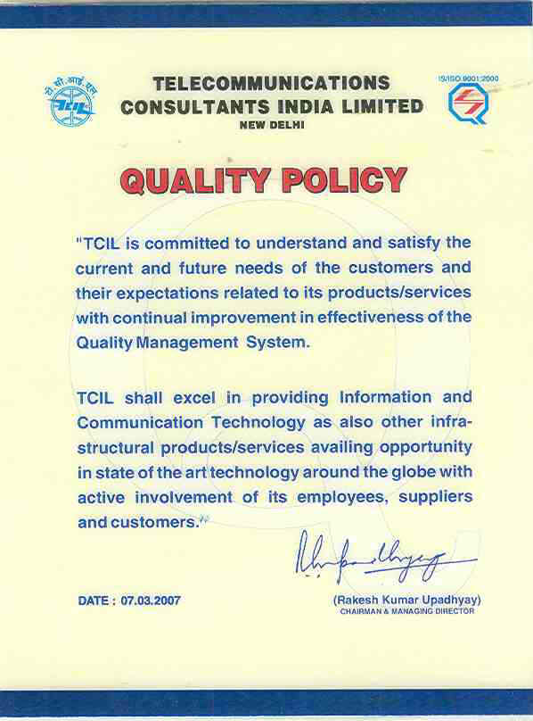

1.PREFACE

An effective complaints management system is integral to providing quality customer service. It helps to measure customer satisfaction and is a useful source of information and feedback for improving services. Often customers are the first to identify when things are not working properly.

The project tries to accomplish all the following features:

1) Smooth flow of data without any hurdles.
2) Adequate validation checks for data entry.
3) Adequate security of data.
4) Facility to update data from time to time.
5) Prompt and specific retrieval of data.
6) Flexibility in the system according to the changing environment.
7) Controlling redundancy in storing the same data multiple times.
8) Accuracy, timeliness and comprehensiveness of the system output.
9) Stability and operability by people of average intelligence.
10) Enhancement in the completion of work within the constraints of time

The scope of the system is quite wide. It can be implemented on a WAP-enabled mobile handset, thus providing the Customers and the Providers, the ease of accessing the projects and their status without any difficulty and within no time.

Index
S.No. Name of the topic Page no.

1. Introduction
1.1 Objectives and scope of the project 7
1.2 Theoretical Background 9
1.3 Definition of the problem 10
2. System Analysis (Hardware & Software Requirement)
2.1 System Analysis Introduction 16
2.2 Software Requirement Specification 18
2.3 Feasibility Study 19
2.4 Choice Of Platform 24
3. Methodology Adopted (System Design)
3.1 Methodology Adopted 28
3.2 Architectural Design 31
3.3 Process Design 41
4. System Implementation
4.1 Implementation 47
4.2 Implementation Tools 48
4.3 Testing 52
4.4 Maintenance 53
5. Result And Discussions
6.1 Conclusion 54
6.2 Future Scope 56
7. Annexure
7.1 Screen Shots and Coding 57

8. Bibliography
7.1 Books 72
7.2 URLs 73

1.3 Definition Of The Problem
To define the problem we have to study the existing system ,the problems in the existing system and the needs of the system. After this we will explain the proposed system. Following Points Are defined for the definition of problem:
1. Existing System
2. Needs of the system
3. Proposed system

1.3.1. EXISTING SYSTEM
This software has been developed for a cellular company Concerning all the details given by company. By this software anyone can handle customer complaint details without any difficulty. To maintain customer complaint details and to generate the complaint report to the clients they have to maintain the following information in various files:
In the first file they record the client’s personnel information, such as client code, client name, address, etc. this details are entered in this file when the new client comes into the organization.
The second file is used to record the product details of each individual product, this file, this file contain the detail like the product code and all other details concerning about products.
The third file records the complaints of the customers, which we received from the customers. Each complaint is assigned a separate a CCR No. I.e. Customer Complaint Number. This file records the detailed description of the complaint. Against each CCR No.

1.3.2. NEED FOR SYSTEM
The package that I designed can handle the Complaints details without any difficulty & with a little bit of effort. As the work is one manually before, so it will be very time consuming & required a large efforts to maintain the files. By computerizing the system these files can be handled with a small effort & in less time.
The chances of duplicity of complaints are negligible. The Customer Complaint Report can be generated easily by getting the information without any problem from all the related files. The package is designed by using GUI concept there for it is very user friendly & easy to use.

1.3.3. PROPOSED SYSTEM
The package that I designed can handle the Complaints details without any difficulty & with a little bit of effort. As the work is one manually before, so it will be very time consuming & required a large efforts to maintain the files. By computerizing the system these files can be handled with a small effort & in less time. The chances of duplicity of complaints are negligible. The Customer Complaint Report can be generated easily by getting the information without any problem from all the related files. The package is designed by using GUI concept there for it is very user friendly & easy to use.

Planning information systems has become increasingly important because information is a vital resource & company asset, more & more funds are committed to information system & system development is a serious business for computers that incorporate databases & networking. The initial investigation has the objectives of determining the validity of the user request for a candidate system & whether a feasibility study should be conducted. The objective of the problem posed by the user must be understood within the framework of the organizations MIS plan.

Fact- finding is the first step in the initial investigation. It includes a review of written documents, on site observation, interviews & the questionnaires. The next step is fact analysis, which evaluates the element, related to the input & the output of the given system. Data flow diagrams & other charts are prepared during this stage .The outcome of initial investigation is to determine whether an alternative system is feasible. The proposal details the findings of the investigation. Approval of the document initiates a feasibility study, which leads to the selection of the best candidate system.
1.3.3.1 Benefits Of The Proposed System
The benefits of the proposed system must also be evaluated. Benefits may be categorized as tangible or intangible.
Tangible benefits that are measured in money terms consist of the saving of
- Time.
- Certain operating costs.

Intangible benefits are more difficult to estimate and justify. They are often impossible to give a money value to.
These may include –
- Satisfaction of the customers
Efficiency in handling complaints

INTRODUCTION
1.1 Objectives and scope of the Project
An effective complaints management system is integral to providing quality customer service. It helps to measure customer satisfaction and is a useful source of information and feedback for improving services. Often customers are the first to identify when things are not working properly.
Implementing effective complaints management systems within public sector agencies:
- Improves Companies internal complaints handling
- Reduces recurring complaints
- Improves standards of service to the community
- Raises standards of administrative decision-making

The following objectives have been set:
1) Smooth flow of data without any hurdles.
2) Adequate validation checks for data entry.
3) Adequate security of data.
4) Facility to update data from time to time.
5) Prompt and specific retrieval of data.
6) Flexibility in the system according to the changing environment.
7) Controlling redundancy in storing the same data multiple times.
8) Accuracy, timeliness and comprehensiveness of the system output.
9) Stability and operability by people of average intelligence.
10) Enhancement in the completion of work within the constraints of time

The scope of the system is quite wide. It can be implemented on a WAP-enabled mobile handset, thus providing the Customers and the Providers, the ease of accessing the projects and their status without any difficulty and within no time.
1.2 Theoretical Background
A good complaints management system is one of the crucial requirements for successful businesses when managing customers’ needs and protecting their brand. Through the implementation, assessment, certification and training of a complaints management system we can help you to make big leaps in delivering customer satisfaction.“A complaint is an expression of dissatisfaction made to an organization, related to its products, or the complaints handling process itself, where a response or resolution is explicitly implicitly expected." Definition from ISO 10002:2004
It costs an organization at least four times as much to recruit a new customer as to maintain an existing one. Organizations that regularly lose customers struggle to repair their damagedreputations.
In today’s competitive environment, product and service innovations are re-defining accepted levels of performance. A good Complaints Management System is one of the crucial requirements for successful businesses when managing customers’ needs and protecting their brand.
Effective complaint management is fundamental to the provision of quality service. Complaints systems provide a mechanism for obtaining feedback from customers, resolving disputes and reforming policies and procedures.
Complaints management is a vital component of every decision-making framework and is especially relevant to agencies that have service-oriented roles in the public sector. With increasing expectations from the public, agencies need to respond to complaints in an effective and timely way.

1.3.3.2 Methodology Adopted
Prototyping Model has been used for software development according to which a throwaway prototype of the proposed system, based on the currently known requirements, is given to the user so that he has a fair idea about how the proposed system is going to be like. This will help him in deciding the interface, input and output requirements.
It can be easily adjudged that inputs and outputs are big in number, can increase exponentially and may create a big chaos if not restricted properly. As the user spends some time on the prototype, he will become more precise about his own inpu output Requirements. This prototype will provide him with an environment analogous to the proposed system’s environment.
Due to object oriented support in .NET, various concepts (like reusability, polymorphism, isolation etc.) are already there but for the efficient management of system components, Component based Software Engineering will also be exercised which will help in a resultant library of components, the benefit of which will be reusability and fast development.
Due to lack of hierarchical structure in object oriented approach, there is no meaning of Bottom-up or Top-down testing. Testing will begin from the rudimentary levels of the system and will move towards higher level components, which will be based on design phase rather than coding phase Words.

1.3.3.3 Working Environment:
1.3.3.3.1 Understanding .Net Frame Work
The .Net framework can be defined as a language neutral platform designed to provide a number of rich and powerful application development tools and technologies. It has an extensive class library that provides wide-ranging support for data access..Net framework has an independent code execution and management environment called the Common Language Runtime (CLR) which ensures that code is safe to run, and provides an abstract layer on top of the operating system, which allows the elements of the .Net framework to run on many operating systems and devices.
1.3.3.3.2 Microsoft SQL Server™ 2005
Microsoft SQL Server 2005 is a full-featured relational database management system (RDBMS) that offers a variety of administrative tools to ease the burdens of database development, maintenance and administration. In this article, we'll cover six of the more frequently used tools: Enterprise Manager, Query Analyzer, SQL Profiler, ervice Manager, Data Transformation Services and Books Online.

1.3.3.4 Key Tasks Of The Project:
- To prepare database.
- To prepare stored procedures.
- To prepare Business Logic Layer.
- To prepare web pages.
- To handle the control navigation from other pages
- Writing the Code Behind pages for the web pages.
- Database Design
- Writing Stored Procedures.
- Apply all the check constraints according to the requirements.
- Designing all the classes for Business Logic Layer (BLL).



SYSTEM ANALYSIS ( H/W & S/W )

2.1 System Analysis Introduction
System analysis is the process of studying the business processors and procedures, generally referred to as business systems, to see how they can operate and whether improvement is needed.This may involve examining data movement and storage, machines and technology used in the system, programs that control the machines, people providing inputs, doing the processing and receiving the outputs.
2.1.1 Investigation Phase
The investigation phase is also known as the fact-finding stage or the analysis of the current system. This is a detailed study conducted with the purpose of wanting to fully understand the existing system and to identify the basic information requirements. Various techniques may be used in fact-finding and all fact obtained must be recorded. A thorough investigation was done in every effected aspect when determining whether the purposed system is feasible enough to be implemented.
2.1.1.1 Investigation
As it was essential for us to find out more about the present system, we used the following methods to gather the information: -
1. Observation: - Necessary to see the way the system works first hand.
2. Document sampling: - These are all the documents that are used in the system. They are necessary to check all the data that enters and leaves the system.
3. Questionnaires: - These were conducted to get views of the other employees who are currently employed in the system.

2.1.2 Analysis Of The Investigation
Strengths of the System
1. No complex equipment: - The equipment that is used is very simple and no special skills have to be mastered to be able to operate the system. Therefore no training is required for the employees.
2. Low cost: - There is little money spent in maintaining the present system other than buying the necessary office equipment and the ledgers.
2.1.3 Constraints And Limitations
The constraints and limitation within a system are the drawbacks that occur during the implementation of the system. These limitations and constraints can crop up in almost every system; the most important fact is to find a way to overcome these problems.
Software design is the first of three technical activities – design, code generation, and test that are required to build and verify the software. Each activity transforms information in manner
that ultimately results in validated computer software.
The design task produces a data design, an architectural design, an interface design and component design. The design of an information system produces the details that clearly describe how a system will meet the requirements identified during system analysis. The system design process is not a step by step adherence of clear procedures and guidelines. When I started working on system design, I face different types of problems; many of these are due to constraints imposed by the user or limitations of hardware and software available. Some times it was quite difficult to enumerate that complexity of the problems and solutions thereof since the variety of likely problems is so great and no solutions are exactly similar however the following consideration I kept in mind during design phased.

2.2 Software Requirement Specification
The software requirement specification is produced at the culmination of the analysis task. The function and performance allocated to software as part of system engineering are refined by establishing a complete information description, a detailed functional description, a representation of system behavior, an indication of performance requirement and design constraints appropriate validation criteria, and other information pertinent to requirement.
The introduction to software requirements specification states the goals and objectives of the software, describing it in the context of the computer based system. The Information Description provides a detailed description of the problem that the software must solve. Information content, flow and structure are documented.
A description of each function required to solve the problem is presented in the Functional Description. Validation Criteria is probably the most important and ironically the most often neglected section of the software requirement specification. Software requirement specification can be used for different purpose.
2.2.1 Statement of user needs:
A main purpose of the product specification is to define the need of the product’s user. Some times, the specification may be a part of a contract sign between the producer and the user. It could also form part of the user manuals. A user‘s needs are sometimes not clearly understood by the developer. If this is the case, a careful analysis – involving much interaction with the user should be devoted to reaching a clear statement of requirements, in order to avoid possible misunderstandings. Sometimes, at the beginning of a project, even the user has no clear idea of what exactly the desired product is. Think for instance of user interface , a user with no previous experience with computer products may not appreciate the difference between , say menu driven interaction and a command line interface. Even an exact formation of system functions and performance may be missing an initial description produced by an experienced user.

2.3 Feasibility Study

2.3.1 System feasibility
Prior to stating whether the system we have to develop is feasible or not we believe that we should emphasize on what is implied by the word “Feasibility”. Feasibility is the measure of how beneficial or practical the development of the system will be to the organization. It is a preliminary survey for the systems investigation. It aims to provide information to facilitate a later in-depth investigation.
Types
There are various measures of feasibility that helps to decide whether a particular project is feasible
or not. These measures include –
1. Operational Feasibility
2. Technical Feasibility
3. Economical Feasibility

Each of these types will be explained in detail throughout the project report
2.3.2 Operational Feasibility
A proposed system is beneficial only if it can be turned into an information system that will meet the operational requirements of an organization. A system often fails if it does not fit within existing operations and if users resist the change.
Important issues a systems developer must look into are:
- Will the new system be used if implemented in an organization?
- Are there any major barriers to implementation or is proposed system accepted without destructive resistance?
The whole purpose of computerizing the Complaint Management is to handle the work much more accurately and efficiently with less time consumption. There will be additional work to be completed, because now the cellular company will have to maintain database of both their employees as well as their Customers.
Compared to the semi-computerized system the chances of avoiding errors in a computerized system is much higher because the user need not stress himself unnecessarily resulting in recklessness. Unlike the semi-computerized system there would be backup data for all the information concerning the daily transactions occurred within the organization.
Another important fact to be regarded is the security control, which is handled by the system. Since data regarding each Customer and the Organization is confidential, security is a key issue. Information falling into the wrong hands could jeopardize the entire organization. Unlike in semi-computerized systems
The proposed system offers adequate control to protect the organization against fraud and embezzlement and guarantees the accuracy and Security of data and information. This is handled by the system providing individuals with separate login names and passwords.
The new system is user-friendlier, which enables the end-user to complete his/her work efficiently and accurately with interest. After taking the above fact into consideration we can state the operating of the proposed system within the organization is feasible.
In this phase of the feasibility study the following two main topics
- Technical Performance Aspect and
- Acceptance within the organization
Technical performance aspect is explained in the technical feasibility report and there is no new information is needed in this to explain it again, but as for the acceptance within the organization the following points are important and those are explained according to the topics

Whether the system provides right information to the right place?

In the current system which is the semi computerized system the information may be lost in the process of sending from one place to another. This is mainly due to human interaction in the process of the transferring information from one place to another.

Whether the new system affects the current users in the system?

The new proposed system will affect the users in the following areas
- Accuracy
- Efficiency
- Productivity
- Robustness
- Lesser time consuming

2.3.3 Technical Feasibility
Based on the outline design of the system requirements in terms f inputs, output, Procedures, the technical issues raised during technical feasibility include:
- Does the necessary technology exist to do what is proposed?
- Does the proposed equipment have the technical capacity to hold the data required to use in the new system?
- Adequate responses provided by the proposed system?
- Is the system flexible enough to facilitate expansion?
- Is there any technical guarantee of accuracy, reliability, ease of access and data security?

The system developer’s task is to view needed capabilities in light of currently available technology. Our site works hand in hand with high technology. A database has to be maintained in order to update and backup data whenever required. To create databases we use SQL server. After taking the above facts into consideration we can state that the new proposed system is technically feasible.
2.3.4 Economical Feasibility
In making recommendations a study of the economics of the proposed system should be made. Even though finding out the costs of the proposed project is difficult we assume and estimate the costs and benefits as follows. According to the computerized system we propose, the costs can be broken down in two categories.
1 Costs associated with the development of the system.
2 Costs associated with operating the system.

2.3.4 System Security
System security is a vital aspect when it comes to developing a system. The system should ensure the facility Of preventing unauthorized personnel from accessing the information and the data within the system. The system should provide total protection for each user’s information so that the integrity of data is sustained and also prevent hackers from hacking the system.
The proposed system ensures the security and the integrity of data. This is done by providing a password login system for each authorized users. And for example the System Administrator has access to all kinds of information.
By providing this facility information is properly managed and information is protected. For example the system administrator’s day to day tasks are lessened and easier because he doesn’t have to have a constant eye on the system and worry about hackers hacking the system.
2.4 CHOICE OF PLATFORM
2.4.1 Software Requirement
.NET Framework System Requirements
To ensure adequate performance, .NET Framework has the following minimum and recommended system requirements for client and server applications:
2.4.2 Operating System Requirements:
The .NET Framework is supported on the following platforms:
Scenario | Operating System
Client | MS Windows 98
 | MS Windows 98 Second Edition
 | MS Windows Millennium Edition
 | MS Windows NT 4.0 Workstation with service pack 6.0a or later
 | MS Windows NT 4.0 Server with service pack 6.0 a or later
 | MS Windows 2000 Professional
 | MS Windows 2000 Server
 | MS Windows 2000 Advanced Server
 | MS Windows 2000 Datacenter Server
 | MS Windows XP Home Edition Professional
 | MS Windows Server 2003 Family
Note: On all these systems, MS Internet Explorer 5.01 or later and MS Windows Installer 2.0 or later are also required.
Server | MS Windows 2000 Professional
 | MS Windows 2000 Server with service pack 2.0
 | MS Windows 2000 Advanced Server with service pack 2.0
 | MS Windows 2000 Datacenter Server with service pack 2.0
 | MS Windows XP Professional
 | MS Windows Server 2003 Family

2.4.3 Additional Software Requirements:
To use additional features such as ASP.Net, COM+ services and SQL Server .NET Data Provider, you will need the following additional software’s:
Scenario | Feature | Required Software
Client | SQL Server .Net Data | MS Data Access Components
Provider |  | (MDAC) 2.6 or later
Access to System Management |  | Windows Management
Instrumentation(WMI)
(Installed with OS on Windows 2000, Windows Millennium Edition and Windows XP)
COM + Services |  | Windows 2000 with service pack 2.0
Server | SQL Server .Net Data | MS Data Access Components
Provider |  | (MDAC) 2.7
ASP.Net |  | MS Internet Information Services (IIS) 5.0

2.4.4 Hardware Requirements
Scenario Required | Processor Recommended | Required | Ram Recommended | Required
Client | Pentium 500 MHz* | Pentium 1 GHz | 64 MB* | 256 MB or higher
Server | Pentium 667 MHz* | Pentium 1 GHz | 128 MB* | 256 MB or higher
*Or the minimum required by the operating system, whichever is higher.
Microsoft SQL Server™ 2005
Microsoft SQL Server 2005 is a full-featured relational database management system (RDBMS) that offers a variety of administrative tools to ease the burdens of database development, maintenance and administration. In this article, we'll cover six of the more frequently used tools: Enterprise Manager, Query Analyzer, SQL Profiler, Service Manager, Data Transformation Services and Books Online.

METHODOLOGY ADOPTED

3.1 Methodology Adopted
Prototyping Model has been used for software development according to which a throwaway prototype of the proposed system, based on the currently known requirements, is given to the user so that he has a fair idea about how the proposed system is going to be like. This will help him in deciding the interface, input and output requirements.
It can be easily adjudged that inputs and outputs are big in number, can increase exponentially and may create a big chaos if not restricted properly. As the user spends some time on the prototype, he will become more precise about his own inpu output Requirements. This prototype will provide him with an environment analogous to the proposed system’s environment.
Due to object oriented support in .NET, various concepts (like reusability, polymorphism, isolation etc.) are already there but for the efficient management of system components, Component based Software Engineering will also be exercised which will help in a resultant library of components, the benefit of which will be reusability and fast development.
Due to lack of hierarchical structure in object oriented approach, there is no meaning of Bottom-up or Top-down testing. Testing will begin from the rudimentary levels of the system and will move towards higher level components, which will be based on design phase rather than coding phase Words.

3.1.1 Working Environment:
3.1.1.1 Understanding .Net Frame Work
The .Net framework can be defined as a language neutral platform designed to provide a number of rich and powerful application development tools and technologies. It has an extensive class library that provides wide-ranging support for data access..Net framework has an independent code execution and management environment called the Common Language Runtime (CLR) which ensures that code is safe to run, and provides an abstract layer on top of the operating system, which allows the elements of the .Net framework to run on many operating systems and devices.

3.1.1.1.2 Microsoft SQL Server™ 2005
Microsoft SQL Server 2005 is a full-featured relational database management system (RDBMS) that offers a variety of administrative tools to ease the burdens of database development, maintenance and administration. In this article, we'll cover six of the more frequently used tools: Enterprise Manager, Query Analyzer, SQL Profiler, ervice Manager, Data Transformation Services and Books Online.

3.1.1.1.3 Key Tasks Of The Project:
- To prepare database.
- To prepare stored procedures.
- To prepare Business Logic Layer.
- To prepare web pages.
- To handle the control navigation from other pages
- Writing the Code Behind pages for the web pages.
- Database Design
- Writing Stored Procedures.
- Apply all the check constraints according to the requirements.
- Designing all the classes for Business Logic Layer (BLL).

3.1.1.1.4 Project Organization
This project is divided into four parts which correspond to the four layers of the logical architecture of the project. The users of the project interact with Presentation Layer. The Business Logic Layer(BLL) provides the internal computation of the requirements. The Data Access Layer (DAL) is the intermediate layer which communicates with the DATABASE.
These layers are as follows:-
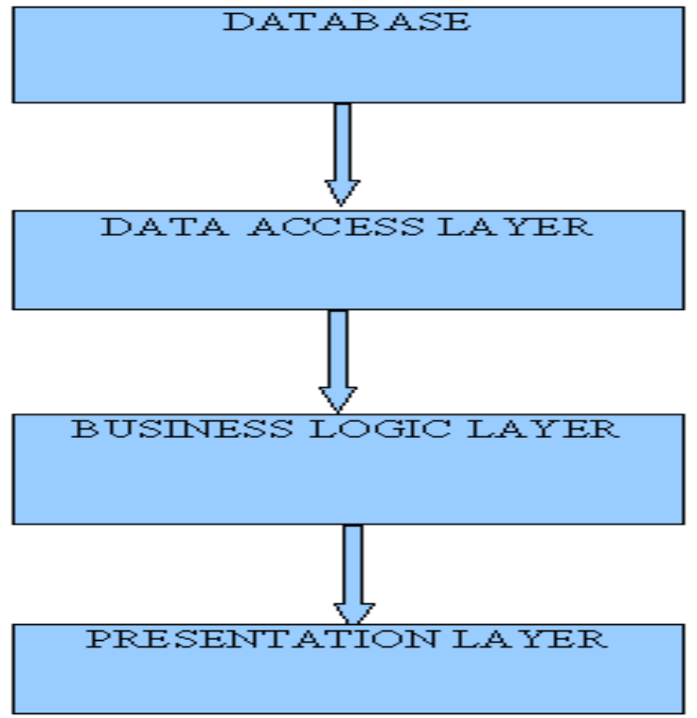

3.2 Architectural Design
Three Layers Of Project:
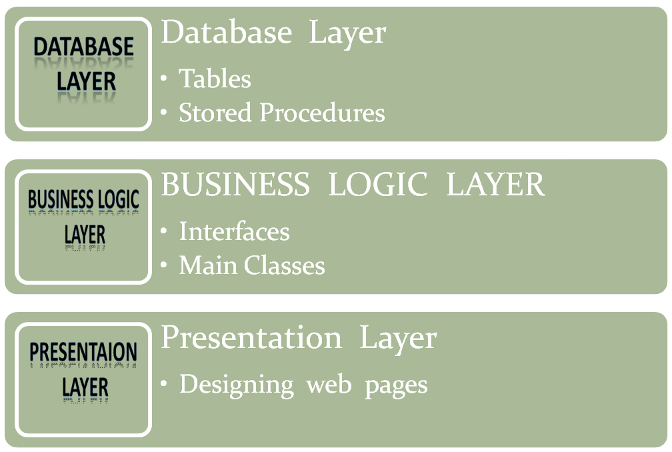

Architectural Diagram
. Net Framework

MFC

ASP

VB FORM

Windows API

3.2.1 Database Design
It includes:
- Tables
- Stored Procedures
1.Tables

- tbcontyp (Connection Table)
Field | Data Type | Size | Key | Description
Contypcod | Int | 4 | Primary Key | Connection code of Connection Type
Contypnam | Varchar | 50 |  | Name of Connection type

- tbpln (Plan table)
Field | Data Type | Size | Key | Description
Plncod | Int | 4 | Primary Key | Plan Code of Plan
Plnnam | Varchar | 50 |  | Name of Plan
Plndsc | Varchar | 200 |  | Description Of Plan
Plntrf | Varchar | 50 |  | Plan Tariff
Plncontypcod | int | 4 | Foreign key | Connection Type Code of Plan

- tbaddons (Addon Table)
Field | Data Type | Size | Key | Description
Addoncod | Int | 4 | Primary Key | Addon On code of Addon
Addonplncod | Int | 4 | Foreign Key | Plan Code of Addon
Addonnam | Varchar | 50 |  | Name Of Addon
Addontrf | Varchar | 50 |  | Addon Tariff
addondsc | Varchar | 200 |  | Description of Addon

4.tbarea (Area Table)
Field | Data Type | Size | Key | Description
Areacod | int | 4 | Primary Key | Area Code Of Area
Areanam | varchar | 50 |  | Name of Area

- tbloc (Location Table)
Field | Data Type | Size | Key | Description
loccod | int | 4 | Primary key | Location Code Of Location
locnam | varchar | 50 |  | Name of Location
Locareacod | int | 4 | Forgein Key | Area Code Of Location

- tbcmptyp (Complaint Type)
Field | Data Type | Size | Key | Description
Cmptypcod | Int | 4 | Primary key | Complaint Type Code
Cmptypnam | Varchar | 50 |  | Name Of Complaint type

- tbemp (Employee Table)
Field | Data Type | Size | Key | Description
Empcod | Int | 4 | Primary Key | Employee Code of Employee
Empadd | Varchar | 200 |  | Address of Employee
Empphn | Varchar | 20 |  | Phone Number Of Employee
Empmob | Varchar | 20 |  | Mobile Number Of Employee
Empeml | Varchar | 50 |  | Email Of Employee
Emppic | Varchar | 50 |  | Picture Of Employee
Empcmptypcod | Int | 4 | Foreign Key | Complaint Type Code Of Employee
Emploccod | int | 4 | Foreign Key | Location Code Of Employee

- tbnewcon (New Connection Table)
Field | Data Type | Size | Key | Description
Newconcod | Int | 4 | Primary Key | Code of new connection
Newconnam | Varchar | 50 |  | Name of New connection (Client)
Newcondat | Datetime | 8 |  | Date of New Connection Apply
Newconplncod | Int | 4 | Foreign Key | Plan Code Of new connection
Newconloccod | Int | 4 | Foreign Key | Location Code of New Connection
Newconphn | Varchar | 50 |  | Phone Number Of New Connection
Newconpic | Varchar | 50 |  | Picture Of New Connection
Newcondsc | Varchar | 100 |  | Description of new connection
Newconsts | Char | 1 |  | Status of New Connection
newconeml | varchar | 50 |  | Email Of New Connection

9.tbcst (Customer Table)
Field | Data Type | Size | Key | Description
Cstcod | Int | 4 |  | Code Of Customer
cstnewconcod | int | 4 | Foreign Key | New Connection Code of Customer

- tbacc (Account Table)
Field | Data Type | Size | Key | Description
Accno | Int | 4 |  | Account Number Of Customer
Acccstcod | Int | 4 | Foreign Key | Customer Cod of Account
Accplncod | Int | 4 | Foreign key | Plan Code Of Account
Acccrtdat | Datetime | 8 |  | Date of Account Create
accphn | varchar | 50 |  | Phone Number Of Account

- tbaccdet (Account Detail Table)
Field | Data Type | Size | Key | Description
Accdetcod | Int | 4 | Primary Key | Account Detail Code
Accdetaccno | Int | 4 | Foreign Key | Account Number Of Account Detail
Accdetaddoncod | Int | 4 |  | Addon Code Of Account Detail
Accdetstrdat | Datetime | 8 |  | Start Date of Addon(Account Detail)
Accdetsts | char | 1 |  | Status of Account Detail

- tbcmp (Complaint Table)
Field | Data Type | Size | Key | Description
Cmpcod | Int | 4 | Primary Key | Complaint Code
Cmpaccno | Int | 4 | Foreign Key | Account Number Of Complaint
Cmpdsc | varchar | 50 |  | Description Of Complaint
Cmplvl | char | 1 |  | Level of Complaint
Cmpcmptypcod | Int | 4 | Foreign Key | Complaint Type Code Of Complaint
Cmpsts | Char | 1 |  | Status Of Complaint
Cmpdat | Datetime | 8 |  | Date of Complaint Register

13.tbcmpasg (Assign Complaint Table)
Field | Data Type | Size | Key | Description
Cmpasgcod | Int | 4 | Primary Key | Code Of Complaint Assign
Cmpasgcmpcod | Int | 4 | Foreign Key | Complaint Code of Complaint Assign
Cmpasgempcod | Int | 4 | Foreign Key | Emp Code Of Complaint Assign
Cmpasgdat | Datetime | 8 |  | Date of Complaint Assign

- tbcmpatd( Complaint Attended)
Field | Data Type | Size | Key | Description
Cmpatdcod | Int | 4 |  | Complaint Attended Code
Cmpatddat | Datetime | 8 |  | Date of Complaint Attended
Cmpatdasgcod | Int | 4 | Foreign Key | Complaint Assign Code of Complaint Attended

15.tbusr (User Table)
Field | Data Type | Size | Key | Description
Usrcod | int | 4 | Primary Key | User Code of User
Usrnam | varchar | 50 |  | Name of User
Usrpwd | varchar | 50 |  | Password Of User
Usrempcstcod | int | 4 | Foreign Key | Employee And Customer code of user
Usrrol | char | 1 |  | Role of User
Naming Convention/Symbols For Tables
      - Each table start with tb.
      - Database name start with db.
      - Three character naming convention is followed for ex. Table name consist of tb and three charcter name which represent the table as tbcat which is used to store the categories.

2. Stored Procedures
There are five kinds of stored procedures for each table. They are:
Insert, Update , Delete, Find, Display

- They are Compiled objects
- Store in database
- Execute in database
- High performance
- Secure
There are five kinds of stored procedures for each table.
Naming Convention/Symbols For Store Procedures
- ins-tablename (for inserting values in the particular tables)
- upd-table name(for updating data in the tables)
- del-table name(for deleting data in the tables)
- fnd-table name(for finding particular data in the tables)
- dsp-table name(for displaying tables data onto screen)

3.2.2 BUISNESS LOGIC LAYER:
This layer consist of dll(dynamic link library) naming ClassLibraryHangout having namespace nshangout and one class naming clscon for connection with sqlserver database and 18 interfaces naming int-tablename having property declaration for each field in the respective table, class naming 18 property class naming cls-tablename-prp which inherit its respective interface for definition of each property declared in the interface, class naming 18 methods class naming cls-tablename which inherit class clscon for definition of methods like : save_rec(), update_rec(), delete_rec(), display_rec(), find_rec() etc. methods.

Dynamic Link Library:
Compiled class
- Reusable Scope:
- Multiple application
- No Graphical user interface
- In process component
- Self described

3.2.3 PRESENTATION LAYER:
Presentation layer consists of web pages which include:

MASTER PAGES:
1. Master Page is Common Template that can be implemented on more than one Page. We can make
changes whenever needed.
2. Master page extension is. Master
3. It can never be start up page.
4. We can create properties, methods, classes in master pages.
5. Multiple master pages can be there in single application.

CONTENT PAGES:
1. Content pages are web pages which can be made as startup page.
2. Content page extension is .aspx
3. Multiple content pages can be there in single master page

3.3 Process Design
3.3.1 Data Flow Diagram
In our DFD, we give names to data flows, processes, and data stores. Although the names are descriptive of the data, they do not give details. So the following the DFD, our interest is to build some structured place to keep details of the contents of data flow, processes, and data store. A data dictionary is a structured repository of data about data. It is a set of rigorous definition of all DFD data element and data structure
DFD Symbols
In the DFD, there are four symbols,
- A Square defines a source (originator) or destination of system data.
- An Arrow identifies data flow- data in motion .It is pipeline through which information flows.
- A circle or a bubble (or a oval bubble) represents a process that transforms incoming data flow(s) into outgoing data flow(s)
- An Open rectangle is a data store-data at rest, or temporary repository of data.
The DFD was first developed by “Larry Constatine” as a way of expressing system requirements in a graphical form. A DFD, also referred to as a bubble chart has a purpose of clarifying system requirements and identifying major transformations that will become the program in this system design.

A square defines a source of destination or system data.

- An arrow line identifies the data flow or data in motion. It is a pipeline through which
information flows.

- A circle or bubble represents a process transform incoming data flow in to outgoing data flow.

- A horizontal line represents data stored or data at rest or a temporary rest repository of
data.

- An open rectangle refers to the database storage

DATA FLOW DIAGRAM - 1

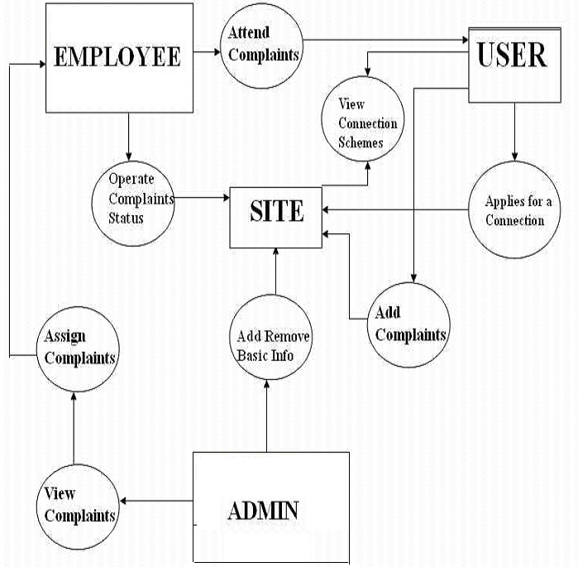

DATA FLOW DIAGRAM - 2

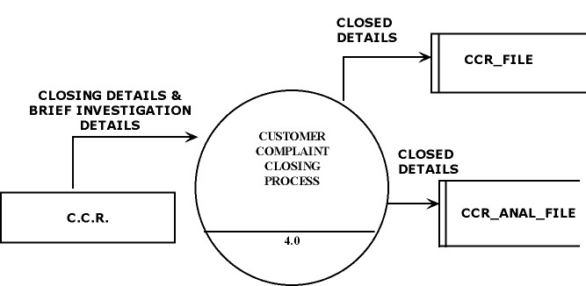
3.3.2. E-R(Entity-Relationship) Diagram
As a database designer, one should use an Entity Relationship (ER) diagram as a tool to build the logical database design of a system. An ER diagram represents the following three elements:
Entities: An entity is an object with a distinct set of properties that is easily identified.
Attributes: An attribute is a property of an entity that differentiates it from other entities and provides information about the entity.
Relationships: A relationship is a crucial part of the design of database.
E-R DIAGRAM

E-R DIAGRAM
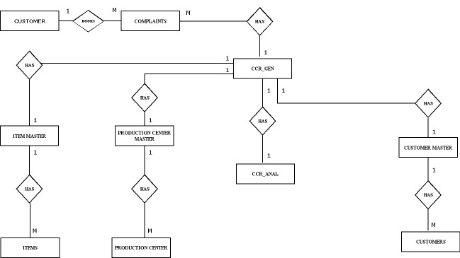


SYSTEM IMPLEMENTATION

4.1 Implementation
Implementation is the stage in the project where the theoretical design is turned into the working system and is giving confidence to the new system for the users i.e. will work efficiently and effectively. It involves careful planning, investigation of the current system and its constraints on implementation, design of method to achieve the change over, an evaluation, of change over methods. A part from planning major task of preparing the implementation is education of users. The more complex system is implemented, the more involved will be the system analysis and design effort required just for implementation. An implementation coordinating committee based on policies of individual organization has been appointed. The implementation process begins with preparing a plan for the implementation for the system. According to this plan, the activities are to be carried out, discussions may regarding the equipment has to be acquired to implement the new system

Implementation is the final and important phase. The most critical stage is in achieving a successful new system and in giving the users confidence that the new system will work and be effective. The system can be implemented only after thorough testing is done and if it found to working according to the specification. This method also offers the greatest security since the old system can take over if the errors are found or inability to handle certain types of transaction while using the new system.

The major elements of implementation plan are test plan, training plan, equipment installation plan, and a conversion plan.

There are three types of implementation:

Implementation of a computer system to replace a manual system.

Implementation of a new computer system to replace an existing system.

Implementation of a modified application to replace an existing one, using the same computer.
Successful implementation may not guarantee improvement in the organization using the new system, but improper installation will prevent it. It has been observed that even the best system cannot show good result if the analysts managing the implementation do not attend to every important detail. This is an area where the systems analysts need to work with utmost care.

4.2.Implementation Tools:
- Training personnel
- Conversion Procedures
- Post-implementation review
4.2.1.Training of Personnel involved with system
Even well designed system can succeed or fail because of the way they are operated and used. Therefore, the quality of training received by the personal involved with the system in various capacities helps or hinders and may even prevent the successful implementation of management information system.

System Operators Training
Running of the system successfully depend on the personnel working in the Computer Centre. They are Responsible for providing the necessary support. Their training must ensure that they are able to handle all possible operations, both routine and extra-ordinary in nature.
If the system calls for the installation of new equipment, such as new computer system, special terminals or different data entry machines, the operators training should include such fundamentals as how to turn the equipment on and use it, how to power off and a knowledge of what constitutes normal operations. The operators should also be trained on different type of malfunctioning, how to recognize them and what steps should also be taken whenever they arise.

User Training
User may be trained on use equipment, particularly in the case where, e.g. a micro computer is in use and individual involved is both operator and user. In such cases, user must be given training on how to operate and user. In such cases, user must be given training on how to operator the system also. Questions that may be trivial to the analyst, such as how to turn on a terminal, how to insert a diskette into a micro-computer or when it is safe to turn off equipment with out danger of data loss are significant problems to new users who are not familiar.
Inmost of the cases user training deals with the operation of the system itself, with proper attention given to data handling techniques. It is imperative that users be properly trained in methods of entering transaction, editing data, formulating inquiries, deleting and inserting of records. No training is complete without familiarizing users with simple systems maintenance activities. Weakness in any aspect of training may lead of awkward situation that creates user frustration and error.

4.2.2 Conversion Methods
A conversion is the process of changing from the old system to the new one. It must be properly planned and executed. Four methods are common in use. They are Parallel Systems, Direct Conversion, Pilot System and Phase In method. Each method should be considered in the light of the opportunities that it offers and problems that it may create. In general, system conversion should be accomplished in shortest possible time. Long conversion periods create problems for all persons involved including both analysts and users.

Parallel Systems:
The most secure method of converting from an old to new system is to run both systems in parallel. This method is safest one because it ensures that in case of any problem in using new system, the organization can still fall back to the old system without the loss of time and money.
The Disadvantages Of Parallel Systems Approach Are:
- It doubles operating costs.
- The new system may not get fair trial.

Direct conversion:
This method converts from the old system to new system abruptly, sometimes over a weekend or even overnight. The old system is used until a planned conversion day, when it is replaced by the new system.

Pilot System:
Pilot approach is often preferred in the case of the new system which involves new techniques or some drastic changes in organization performance. In this method, a working version of the system is implemented in one part of the organization, such as a single work area or department.

Phase –IN- Method:
This method is used when it is not possible to install a new system throughout an organization all at once. The conversion of files, training of personnel or arrival of equipment may force the staging of the implementation over a period of time, ranging from weeks to months.
4.2.3 Post Implementation Review
After the system is implemented and conversion is complete, a review should be conducted to determine whether the system is meeting expectations and where improvements are needed. A post implementation review measures the systems performance against predefined requirement. It determines how well the system continues to meet the performance specifications.

4.3 Testing Phase
The basic goal of the software development process is to produce software that has no errors or very few errors. In an effort to detect errors soon after they are introduced, each phase ends with verification activity such as a review.

As testing is the last phase before the final software is delivered, it has the enormous responsibility of detecting any type of error that may in the software. A software typically undergoes changes even after it has been delivered. And to validate that a change has not affected some old functionality of software regression testing is performed

Levels Of Testing:
The basic levels of testing are unit testing, integration testing and system and acceptance testing. These different levels of testing attempt to detect different types of faults.
Client Needs | Acceptance Testing
Requirements | System Testing
Design | Integration Testing
Code | Unit Testing
4.4 Maintenance
Once the website is launched, it enters the maintenance phase. All systems need maintenance. Maintenance is required because there are often some residual errors remaining in the system that must be removed as they are discovered. Maintenance involves understanding the effects of the change, making the changes to both the code and the documents, testing the new parts and retesting the old parts that were not changed. Maintenance is mainly of two types:

1. Corrective Maintenance
2. Adaptive Maintenance

Corrective Maintenance:
Almost all software that is developed has residual errors or bugs in them. Many of these surfaces only after the system have been in operation, sometimes for a long time. These errors once discovered need to be removed, leading to the software to be changed. This is called Corrective Maintenance.

Adaptive Maintenance:
Even without bugs, software frequently undergoes change. The software often must be upgraded and enhanced to include more features and provide more services. This requires modification of the software. This type of maintenance is known as the Adaptive Maintenance

RESULTS AND DISCUSSIONS

This chapter provides me an opportunity to do self-introspection of what value I have added to my knowledge and skill set and to the project.

6.1 Result (Conclusion)

What value I have added to my knowledge

6.1.1. Domain Experience
TCIL is working on various technologies. Also the individual responsibilities are more. So, I have learnt a lot.

6.1. 2. Exposure to entirely different technology
Working on ASP.NET for the first time was a very enriching experience. I had never worked on this platform earlier. So it added to my list of know how and the computer languages known to me.

6.1. 3. Database Implementation
I had earlier made database but worked on SQL Server for the first time. I learnt many new things about database creation, concept of stored procedure etc. We learn many things theoretically as part of our curriculum but here I got a chance to apply my knowledge practically and enhance it also at the same time.

6.1 .4. Implementation of Business Logic Layer (BLL)
I have implemented the classes for BLL, which provides the interface between UI Layer and Data Access Layer. This layer contains all the business logic, i.e. Programming Methodology to implement the functionality of the system.I had always read about N-Tier architecture but this was again the first time I got to implement 3-Tier logical architecture. So it was a very new and realistic experience.

6.1.5. Implementation of User Interface Layer (UI Layer)
I have also designed the UI layer that contains the web pages designed in Jsp and Java Script. Also it contains the Code Behind pages to implement the programming logic.

Connect Online is very handy tool for connectivity between Client, Employee and Administrator. Communication can be done effectively. Client can apply for a New Connection and can register their complaints to the administrator. Administrator assigns complaints to the concerning employees. Employees will handle the assigned complaints and will report to the Administrator. Connection activation and Complaint handling becomes easier with this site.

As this is Communication site so its application is specific. Applications vary with its type of User who are using it. Since conclusions regarding the project are not so specific but only the main conclusion drawn from the project is that it can be a better Communication site.

Features Of the Project
  - Project is completely secure from Unauthorized access.
  - Perfomance of Project Is much B’coz of the use of stored procedures as compared to queries.

Limitations Of the Project
Due the lack of time,following features could not be added to the project:
    - Chat Facility
    - Deployment of the Project on Pocket-PC i.e. Mobile Application.
6.2 Future Scope
Completion of the development process will result in a software package that will provide user-friendly environment, which is very easy to work with, even for people with very little knowledge of computer.
Management of various tasks is incorporated in the package and will deliver the required information in a very easy to use and easy to access manner.
This package will provide accuracy, efficiency, speed and easiness to the end user. Since the system is verified with valid as well as invalid data and is run with an insight into the necessary modifications that may require in the future, it can be maintained successfully without much
ANNEXURE

Screen Shots and Coding :

Design for Login Page

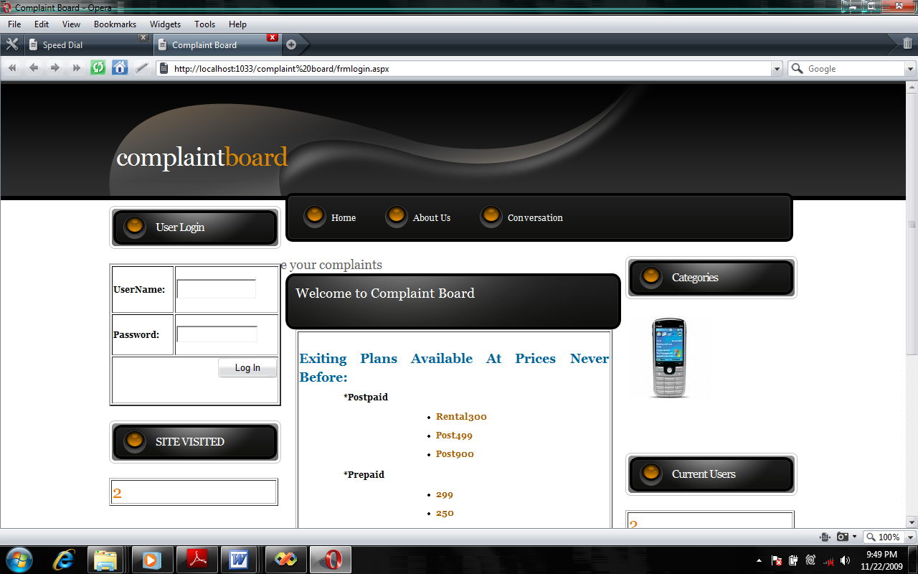

Code :

<%@ Master Language="C#" AutoEventWireup="true" CodeFile="MasterPage.master.cs" Inherits="MasterPage" %>

<html>
<head>
<title>Customer Resource Management </title>
<link href="default.css" rel="stylesheet" type="text/css" media="screen" />
</head>
<body>
<form id="form1" runat="server">
<!-- start header -->
<div id="header">
<div id="logo">
<h1><a href="#">Customer <span> Resource</span> Management </a></h1>
</div>
</div>
<div id="menu">
<ul id="main">
<asp:HyperLink ID="HyperLink1" runat="server" NavigateUrl="~/frmlogin.aspx">Home</asp:HyperLink>
<asp:HyperLink ID="HyperLink2" runat="server">About Us</asp:HyperLink>

</ul>
</div>

<!-- end header -->
<div id="wrapper">
<!-- start page -->
<div id="page">
<div id="sidebar1" class="sidebar">
<ul>
<li>
<h2>
<asp:Label ID="Label3" runat="server" Text=""></asp:Label></h2>
</li>
<li>
<ul>
<asp:ContentPlaceHolder ID="ContentPlaceHolder2" runat="server">
</asp:ContentPlaceHolder>
</ul>
</li>
<li>
<h2>SITE VISITED</h2>
</li>
<li>

<asp:ContentPlaceHolder ID="ContentPlaceHolder3" runat="server">
<table border="1" style="width: 236px">
<tr>
<td>
<asp:Label ID="Label1" runat="server" style="font-size: x-large" Text="Label"
ForeColor="#EC7600"></asp:Label>
</td>
</tr>
</table>
</asp:ContentPlaceHolder>

</li>

</ul>
</div>
<!-- start content -->
<div id="content">
<div class="post">

<h1 class="title"><a href="#">Welcome to Complaint Board</a></h1>
<div class="entry">

<asp:ContentPlaceHolder ID="ContentPlaceHolder1" runat="server">
</asp:ContentPlaceHolder>
</div>
</div>
</div><!-- end content -->
<!-- start sidebars -->
<div id="sidebar2" class="sidebar">
<ul>
<li>
<h2>Categories</h2>
</li>
<li>
<ul>
<asp:ContentPlaceHolder ID="ContentPlaceHolder4" runat="server">
</asp:ContentPlaceHolder>
</ul>
</li>
<li>
<h2>Current Users</h2>
</li>
<li>

<asp:ContentPlaceHolder ID="ContentPlaceHolder5" runat="server">
<table border="1" style="width: 236px">
<tr>
<td>
<asp:Label ID="Label2" runat="server" style="font-size: x-large" Text="Label"
ForeColor="#EC7600"></asp:Label>
</td>
</tr>
</table>
</asp:ContentPlaceHolder>

</li>

</ul>
</div>
<!-- end sidebars -->
<!-- end sidebars -->
<div style="clear: both;">&nbsp;</div>
</div>
<!-- end page -->
&nbsp;</div>

<div id="footer">
<p class="copyright">&copy;&nbsp;&nbsp;2009 All Rights Reserved &nbsp;&bull;&nbsp; Design by Vikrant Sood.</p>
</div>
</form>
</body>
</html>
Design for Admin Panel

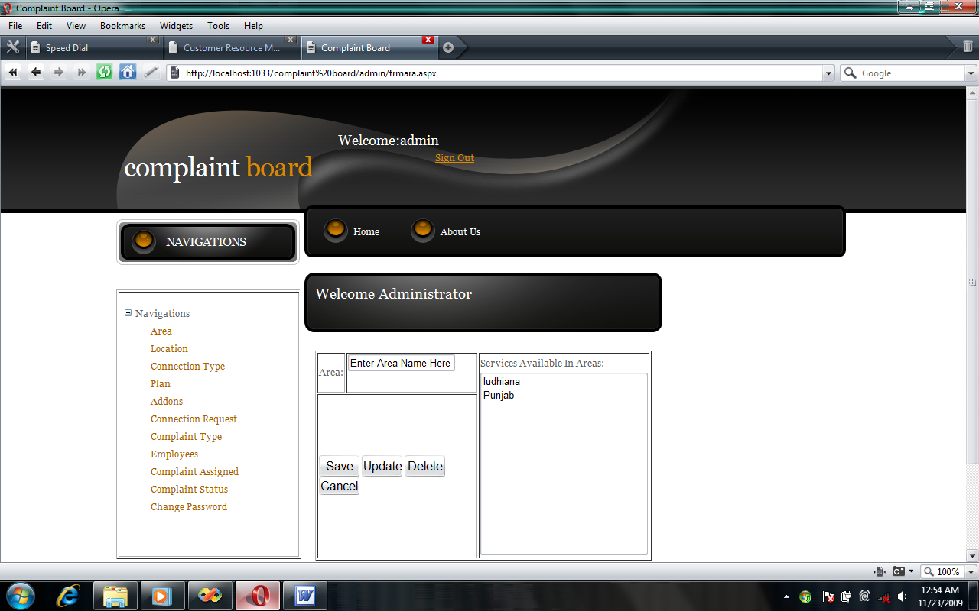
Code :
<%@ Master Language="C#" AutoEventWireup="true" CodeFile="MasterPage.master.cs" Inherits="admin_MasterPage" %>

<html>
<head>
<meta http-equiv="content-type" content="text/html; charset=utf-8" />
<title>Complaint Board</title>
<meta name="keywords" content="" />
<meta name="Cool Black" content="" />
<link href="../default.css" rel="stylesheet" type="text/css" media="screen" />
<style type="text/css">
.style2
{
font-size: large;
}
.style3
{
text-align: left;
}
.style4
{
width: 144%;
height: 30px;
border-style: solid;
border-width: 1px;
}
</style>
</head>
<body>
<form id="form1" runat="server">
<!-- start header -->
<div id="header">
<div id="logo" class="style3">
<h1><a href="#"><span>Complaint </span>Board</a></h1>
&nbsp;&nbsp;&nbsp;&nbsp;&nbsp;&nbsp;&nbsp;&nbsp;&nbsp;&nbsp;&nbsp;<span
class="style2">Welcome:<asp:Label ID="lbusrnam" runat="server" Text=""></asp:Label>
&nbsp;&nbsp;&nbsp;&nbsp;&nbsp;&nbsp;&nbsp;&nbsp;&nbsp;&nbsp;&nbsp;&nbsp;&nbsp;&nbsp;&nbsp;&nbsp;&nbsp;&nbsp;&nbsp;&nbsp;&nbsp;&nbsp;&nbsp;&nbsp;&nbsp;&nbsp;&nbsp;&nbsp;&nbsp;&nbsp;&nbsp;
<br />
&nbsp;&nbsp;&nbsp;&nbsp;&nbsp;&nbsp;&nbsp;&nbsp;&nbsp;&nbsp;&nbsp;&nbsp;&nbsp;&nbsp;&nbsp;&nbsp;&nbsp;&nbsp;&nbsp;&nbsp;&nbsp;&nbsp;&nbsp;&nbsp;&nbsp;&nbsp;&nbsp;&nbsp;&nbsp;&nbsp;&nbsp;&nbsp;&nbsp;&nbsp;&nbsp;&nbsp;&nbsp;&nbsp;&nbsp;
</span>
<asp:LinkButton ID="lksgnout" runat="server" Font-Underline="True"
CausesValidation="False" onclick="lksgnout_Click1"
>Sign Out</asp:LinkButton>
</div>
</div>
<div id="menu">
<ul id="main">
<asp:HyperLink ID="HyperLink1" runat="server" NavigateUrl="~/admin/frmara.aspx">Home</asp:HyperLink>
<asp:HyperLink ID="HyperLink2" runat="server" >About Us</asp:HyperLink>

</ul>
</div>

<!-- end header -->
<div id="wrapper">
<!-- start page -->
<div id="page">
<div id="sidebar1" class="sidebar">
<ul>
<li>
<h2>NAVIGATIONS</h2>
</li>
<li>
<ul>
<asp:ContentPlaceHolder ID="ContentPlaceHolder2" runat="server">
<P>
<table border="1" style="height: 353px" >
<tr>
<td valign="top" >
<asp:TreeView ID="TreeView1" runat="server" DataSourceID="SiteMapDataSource1"
Height="195px" Width="232px">
</asp:TreeView>
</td>
</tr>
</table>
</P>
<P>
<asp:SiteMapDataSource ID="SiteMapDataSource1" runat="server" />
</P>
</asp:ContentPlaceHolder>
</ul>
</li>

</ul>
</div>
<!-- start content -->
<div id="content">
<div class="post">
<h1 class="title"><a href="#">Welcome Administrator</a></h1>
<br />
<div class="entry">
<asp:ContentPlaceHolder ID="ContentPlaceHolder1" runat="server">
</asp:ContentPlaceHolder>
</div>
</div>
</div><!-- end content -->
<!-- start sidebars -->
<div id="sidebar2" class="sidebar">
<ul>
<li>
</li>
</ul>
</div>
<!-- end sidebars -->
<div style="clear: both;">&nbsp;</div>
</div>
<!-- end page -->
</div>
<div id="footer">
<p class="copyright">&copy;&nbsp;&nbsp;2009 All Rights Reserved &nbsp;&bull;&nbsp; Design by Richa</a>.</p>
</div>
</form>
</body>
</html>
Design for Client Panel:

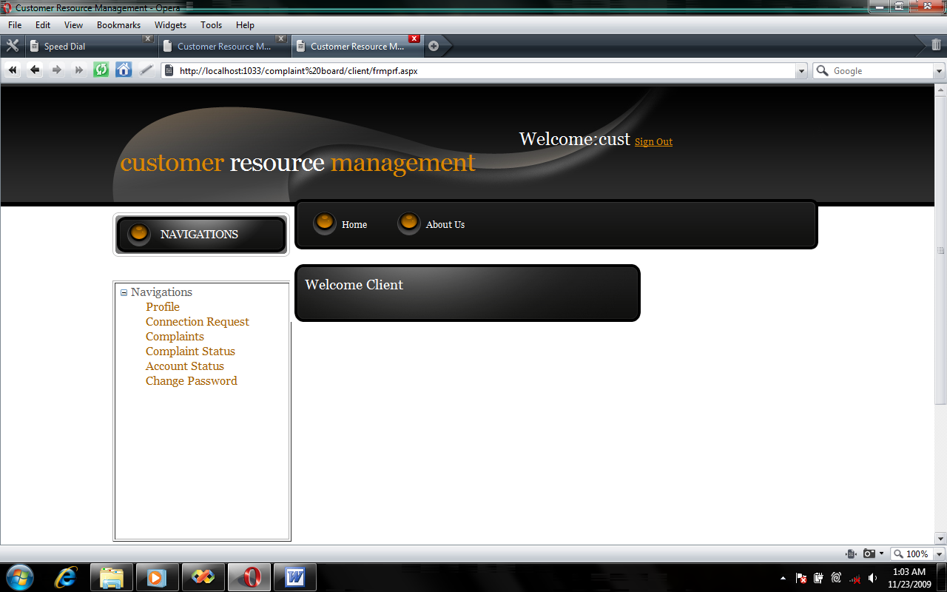
Code :

<%@ Master Language="C#" AutoEventWireup="true" CodeFile="MasterPage.master.cs" Inherits="client_MasterPage" %>

<html>
<head>
<title>Customer Resource Management </title>
<link href="../default.css" rel="stylesheet" type="text/css" media="screen" />
<style type="text/css">
.style2
{
font-size: large;
}
.style3
{
width: 144%;
height: 31px;
border-style: solid;
border-width: 1px;
}
</style>
</head>
<body>
<form id="form1" runat="server">
<!-- start header -->
<div id="header">
<div id="logo">
<h1><a href="#">Customer <span> Resource</span> Management </a></h1>
&nbsp;&nbsp;&nbsp;&nbsp;&nbsp;&nbsp;&nbsp;&nbsp;&nbsp;&nbsp;&nbsp;&nbsp;&nbsp;&nbsp;&nbsp;&nbsp;&nbsp;&nbsp;&nbsp;&nbsp;<span
class="style2">Welcome:<asp:Label ID="lbusrnam" runat="server" Text=""></asp:Label>
</span>
<asp:LinkButton ID="lksgnout" runat="server" Font-Underline="True" onclick="lksgnout_Click1"
>Sign Out</asp:LinkButton>
</div>
</div>
<div id="menu">
<ul id="main">
<li class="current_page_item">
<asp:HyperLink ID="HyperLink1" runat="server"
NavigateUrl="~/client/frmprf.aspx">Home</asp:HyperLink>
</li>
<asp:HyperLink ID="HyperLink2" runat="server">About Us</asp:HyperLink>
</ul>
</div>

<!-- end header -->
<div id="wrapper">
<!-- start page -->
<div id="page">
<div id="sidebar1" class="sidebar">
<ul>
<li>
<h2>NAVIGATIONS</h2>
</li>
<li>
<ul>
<asp:ContentPlaceHolder ID="ContentPlaceHolder2" runat="server">
<P>
<table border="1" style="height: 353px" >
<tr>
<td valign="top" >
<asp:TreeView ID="TreeView1" runat="server" DataSourceID="SiteMapDataSource1"
Height="195px" Width="232px">
</asp:TreeView>
</td>
</tr>
</table>
</P>
<P>
<asp:SiteMapDataSource ID="SiteMapDataSource1" runat="server"
SiteMapProvider="xyz" />
</P>
</asp:ContentPlaceHolder>
</ul>
</li>

</ul>
</div>
<!-- start content -->
<div id="content">
<div class="post">
<h1 class="title"><a href="#">Welcome Client</a></h1>
<br />
<div class="entry">
<asp:ContentPlaceHolder ID="ContentPlaceHolder1" runat="server">
<table class="style3">
<tr>
<td>
&nbsp;</td>
</tr>
</table>
</asp:ContentPlaceHolder>
</div>
</div>
</div><!-- end content -->
<!-- start sidebars -->
<div id="sidebar2" class="sidebar">
<ul>
<li>
</li>
</ul>
</div>
<!-- end sidebars -->
<div style="clear: both;">&nbsp;</div>
</div>
<!-- end page -->
</div>
<div id="footer">
<p class="copyright">&copy;&nbsp;&nbsp;2009 All Rights Reserved &nbsp;&bull;&nbsp; Design by Vikrant Sood</p>
</div>
</form>
</body>
</html>

Design For Employee Panel

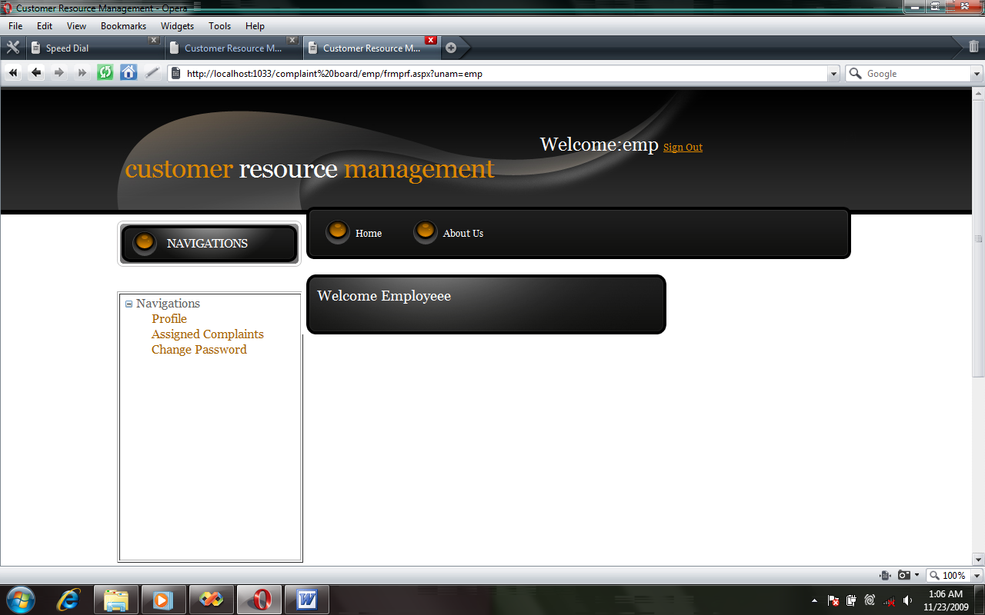

Code :
<%@ Master Language="C#" AutoEventWireup="true" CodeFile="MasterPage.master.cs" Inherits="emp_MasterPage" %>

<html>
<head>
<meta http-equiv="content-type" content="text/html; charset=utf-8" />
<title>Customer Resource Management </title>
<link href="../default.css" rel="stylesheet" type="text/css" media="screen" />
<style type="text/css">
.style2
{
font-size: large;
}
.style3
{
width: 144%;
height: 31px;
border-style: solid;
border-width: 1px;
}
</style>
</head>
<body>
<form id="form1" runat="server">
<!-- start header -->
<div id="header">
<div id="logo">
<h1><a href="#">Customer <span> Resource</span> Management </a></h1>
&nbsp;&nbsp;&nbsp;&nbsp;&nbsp;&nbsp;&nbsp;&nbsp;&nbsp;&nbsp;&nbsp;&nbsp;&nbsp;&nbsp;&nbsp;&nbsp;&nbsp;&nbsp;&nbsp;&nbsp;<span
class="style2">Welcome:<asp:Label ID="lbusrnam" runat="server" Text=""></asp:Label>
</span>
<asp:LinkButton ID="lksgnout" runat="server" Font-Underline="True" onclick="lksgnout_Click1"
>Sign Out</asp:LinkButton>
</div>
</div>
<div id="menu">
<ul id="main">
<li class="current_page_item">
<asp:HyperLink ID="HyperLink1" runat="server" NavigateUrl="~/emp/frmprf.aspx">Home</asp:HyperLink>
</li>
<asp:HyperLink ID="HyperLink2" runat="server">About Us</asp:HyperLink>
</ul>
</div>

<!-- end header -->
<div id="wrapper">
<!-- start page -->
<div id="page">
<div id="sidebar1" class="sidebar">
<ul>
<li>
<h2>NAVIGATIONS</h2>
</li>
<li>
<ul>
<asp:ContentPlaceHolder ID="ContentPlaceHolder2" runat="server">
<P>
<table border="1" style="height: 353px" >
<tr>
<td valign="top" >
<asp:TreeView ID="TreeView1" runat="server" DataSourceID="SiteMapDataSource1"
Height="195px" Width="232px">
</asp:TreeView>
</td>
</tr>
</table>
</P>
<P>
<asp:SiteMapDataSource ID="SiteMapDataSource1" runat="server"
SiteMapProvider="pqr" />
</P>
</asp:ContentPlaceHolder>
</ul>
</li>

</ul>
</div>
<!-- start content -->
<div id="content">
<div class="post">
<h1 class="title"><a href="#">Welcome Employeee</a></h1>
<br />
<div class="entry">
<asp:ContentPlaceHolder ID="ContentPlaceHolder1" runat="server">
<table class="style3">
<tr>
<td>
&nbsp;</td>
</tr>
</table>
</asp:ContentPlaceHolder>
</div>
</div>
</div><!-- end content -->
<!-- start sidebars -->
<div id="sidebar2" class="sidebar">
<ul>
<li>
</li>
</ul>
</div>
<!-- end sidebars -->
<div style="clear: both;">&nbsp;</div>
</div>
<!-- end page -->
</div>
<div id="footer">
<p class="copyright">©&nbsp;&nbsp;2009 All Rights Reserved &nbsp;•&nbsp; Design by Vikrant Sood</p>
</div>
</form>
</body>
</html>

Interface:
public interface intcontyp
{
Int32 contypcod
{
get;
set;
}
String contypnam
{
get;
set;
}
}
Property Class
public class clscontypprp : intcontyp
{
private Int32 prvcontypcod;
private String prvcontypnam;
#region intcontyp Members

public int contypcod
{
get
{
return prvcontypcod;
}
set
{
prvcontypcod = value;
}
}

public string contypnam
{
get
{
return prvcontypnam;
}
set
{
prvcontypnam = value;
}
}

#endregion
}
Connection Class:
public abstract class clscon
{
protected SqlConnection con = new SqlConnection();
public clscon()
{
con.ConnectionString = ConfigurationManager.ConnectionStrings["cn"].ConnectionString;
}
}

Main Class:
public class clscontyp : clscon
{
public void save_rec(clscontypprp p)
{
if (con.State == ConnectionState.Closed)
{
con.Open();
}

SqlCommand cmd = new SqlCommand("inscontyp", con);
cmd.CommandType = CommandType.StoredProcedure;
cmd.Parameters.Add("@contypnam", SqlDbType.VarChar, 50).Value = p.contypnam;
cmd.ExecuteNonQuery();
cmd.Dispose();
con.Close();
}
public void update_rec(clscontypprp p)
{
if (con.State == ConnectionState.Closed)
{
con.Open();
}

SqlCommand cmd = new SqlCommand("updcontyp", con);
cmd.CommandType = CommandType.StoredProcedure;
cmd.Parameters.Add("@contypcod", SqlDbType.Int).Value = p.contypcod;
cmd.Parameters.Add("@contypnam", SqlDbType.VarChar, 50).Value = p.contypnam;
cmd.ExecuteNonQuery();
cmd.Dispose();
con.Close();
}
public void delete_rec(clscontypprp p)
{
if (con.State == ConnectionState.Closed)
{
con.Open();
}

SqlCommand cmd = new SqlCommand("delcontyp", con);
cmd.CommandType = CommandType.StoredProcedure;
cmd.Parameters.Add("@contypcod", SqlDbType.Int).Value = p.contypcod;
cmd.ExecuteNonQuery();
cmd.Dispose();
con.Close();
}
public List<clscontypprp> disp_rec()
{
if (con.State == ConnectionState.Closed)
{
con.Open();
}
SqlCommand cmd = new SqlCommand("dspcontyp", con);
cmd.CommandType = CommandType.StoredProcedure;
SqlDataReader dr = cmd.ExecuteReader();
List<clscontypprp> obj = new List<clscontypprp>();
while (dr.Read())
{
clscontypprp k = new clscontypprp();
k.contypcod = Convert.ToInt32(dr[0]);
k.contypnam = dr[1].ToString();
obj.Add(k);
}
dr.Close();
cmd.Dispose();
con.Close();
return obj;

}

public List<clscontypprp> find_rec(Int32 contypcod)
{
if (con.State == ConnectionState.Closed)
{
con.Open();
}
SqlCommand cmd = new SqlCommand("fndcontyp", con);
cmd.CommandType = CommandType.StoredProcedure;
cmd.Parameters.Add("@contypcod", SqlDbType.Int).Value = contypcod;
SqlDataReader dr = cmd.ExecuteReader();
List<clscontypprp> obj = new List<clscontypprp>();
if (dr.HasRows)
{
dr.Read();
clscontypprp k = new clscontypprp();
k.contypcod = Convert.ToInt32(dr[0]);
k.contypnam = dr[1].ToString();
obj.Add(k);
}
dr.Close();
cmd.Dispose();
con.Close();
return obj;

}
}

BIBLIOGRAPHY

1.Books
1 .CS-Infotech Manual 2007
2. Title-Software Engineering,A Practitioners Approach
Author-Rogers Pressman
Publisher- Tata Mc-Graw Hill
Edition- 6th Edition
Year-2008
3. Title-System Analysis And Design
Author-Elias M.Awad
Publisher- Tata Mc-Graw Hill
Year-2002
4. Title-SQL SERVER
Author-Microsoft Press
Publisher- Tata Mc-Graw Hill
Year-2003
5. Title-ASP .Net Unleashed
Author-Stephen Walther
Publisher- Pearsons Education
Edition- 2nd Edition
Year-2004
6. Title-Professional C#
Authors-Robinson,Allen,Gomes,Glynn,Greenvos,Harney,Negal,Skinner and Watran
Publisher- Peat Education and Shroof Publishers & Distributers Ltd.
Year-2004

2. URLs
1. www.asp.net
2. online MSDN
3. www.codeproject.com
4. www.csharpfriend.com
5. www.dotnetspinder.com
6. www.gotdotnet.com

